**Citi Integration Development Status**

# 1. Integration Setup

| **Object Name** | **Object Type** | **Development Type** |
| --- | --- | --- |
| CitiBank Intg. Setup | Table | Custom |
| CitiBank Intg. Keys | Table | Custom |
| CitiBank Intg. Setup | Page | Custom |
| CitiBank Intg. Keys | Page | Custom |
| Citi Intg. Setup Wizard | Page | Custom |
| Citi Intg. Setup Subscribers | Codeunit | Custom |
| CitiBank Intg Certificates | Enum | Custom |

## Table 50140 "CitiBank Intg. Setup"

**Purpose**: To manage the credentials and token details required for the Citi Bank integration, including enabling or disabling the integration and tracking the token's validity. It includes fields for `Client ID`, `Client Secret`, `Integration Enabled`, and `Token Expires At`.

## Table 50141 "CitiBank Intg. Keys"

**Purpose**: To manage and securely store the certificates needed for the Citi Bank integration, including their upload and deletion. It includes fields for certificate details and metadata.

## Page 50140 "CitiBank Intg. Setup"

**Purpose**: To offer a user interface for managing the CitiBank integration setup, allowing users to enable or disable integration and manage setup records.

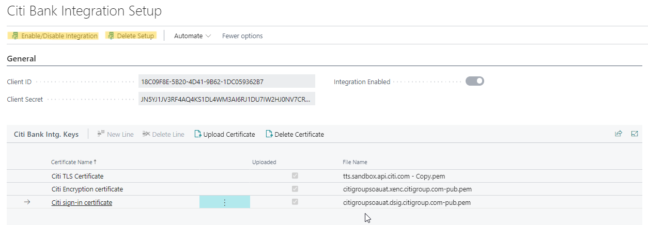

## Page 50141 "CitiBank Intg. Keys"

**Purpose**: To provide a user-friendly interface for managing integration certificates, including uploading new certificates and removing outdated ones.

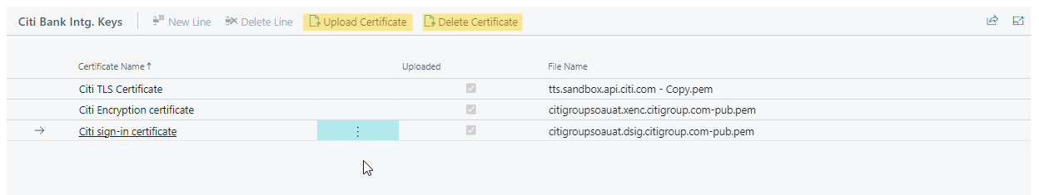

## Page 50100 "Citi Intg. Setup Wizard"

**Purpose**: To guide users through the setup process in an interactive manner, simplifying the configuration of the Citi Bank integration.

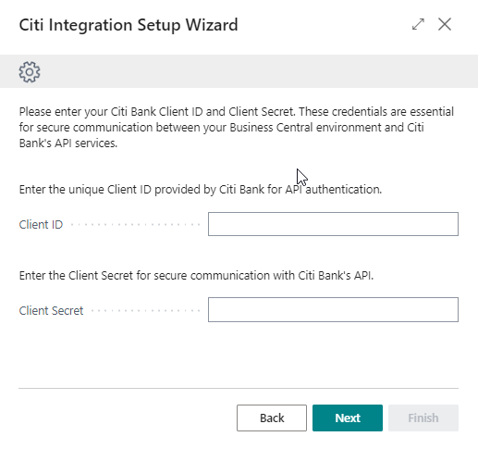

## Codeunit 50100 "Citi Intg. Setup Subscribers"

**Purpose**: To facilitate the execution of the setup wizard and maintain the state of the setup process.

## Enum 50140 "Citi Bank Intg.Certificates"

**Purpose:** The Citi Bank Intg. Certificates enum is designed to manage and categorize the types of certificates used in the Citi Bank integration with Business Central.

# 2. Payment API’s

| **Object Name** | **Object Type** | **Development Type** |
| --- | --- | --- |
| Payment Journal | Page | Extension |
| Citi Payment Init | Xml Port | Custom |
| Citi Intg API Handler | Codeunit | Custom |
| Citi Intg Encryption Handler | Codeunit | Custom |

## Page Extension 50140 “Payment Journal Ext”

**Description:** This page extension for the Payment Journal adds actions for initiating payments and checking/posting payment statuses. It also includes a field for displaying the Payment Request ID.

**Flow:**

1. **Field Addition**:
   * **Field**: Payment Request ID
   * **Purpose**: Displays the payment request ID associated with the payment journal line.
   * **Placement**: Added after the "Document No." field in the layout.
2. **Actions**:
   * **Action Group**: Citi Bank
     + **Actions**: Initiate Payment and Check / Post Status
   * **Action: Initiate Payment**
     + **Purpose**: Initiates payments for selected journal lines.
     + **Trigger**:
       - Iterates through selected journal lines.
       - Call the **InitiatePayment** procedure of **CitiAPIHandler** to get the Payment Request ID.
       - Updates the **Payment Request ID** field in each line.
       - Displays a completion message.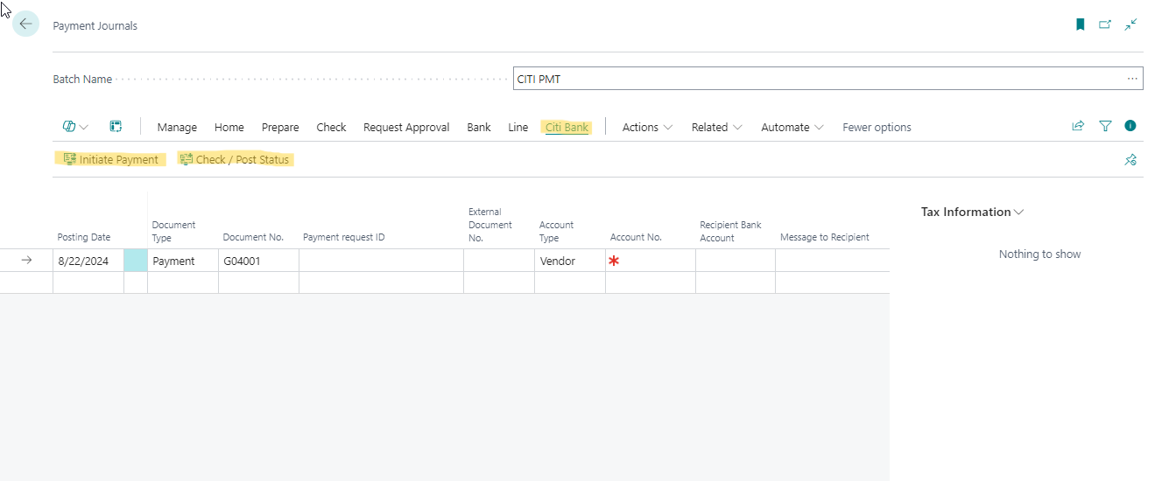

Output after response handling (With Demo Response):

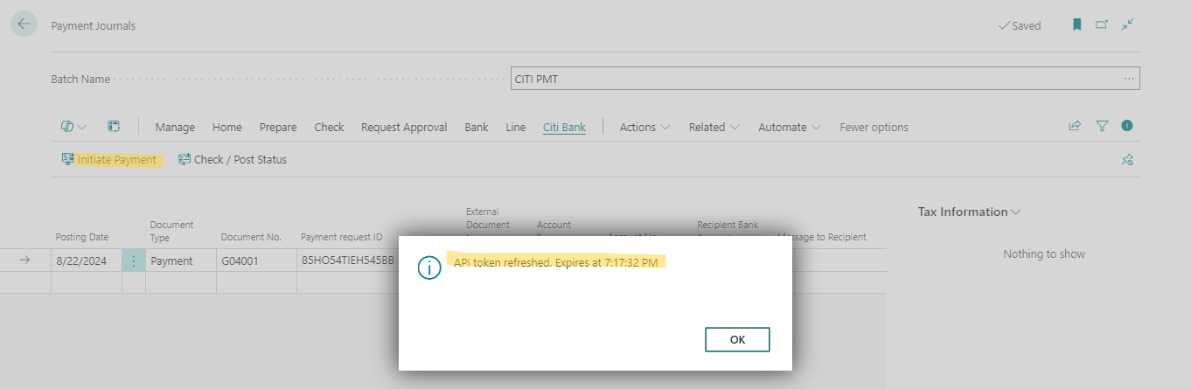

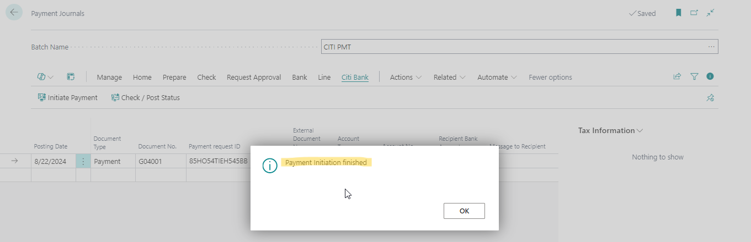

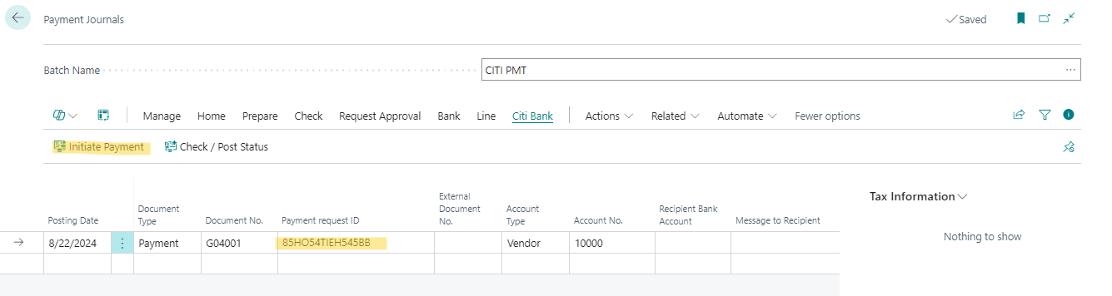

* + **Action: Check/Post Status**:
    - **Purpose**: Checks and posts payment status for selected journal lines.
    - **Trigger**:
      * Iterates through selected journal lines.
      * Calls the **SendEnhancedPaymentStatusInquiry** procedure of **CitiAPIHandler** to get the payment status.
      * **Posts** the journal line if the status is **'ACSP'**.
      * Displays a completion message.
  + **Visibility**:
    - Initiate Payment and Check / Post Status actions are visible if IntegrationEnabled is true.

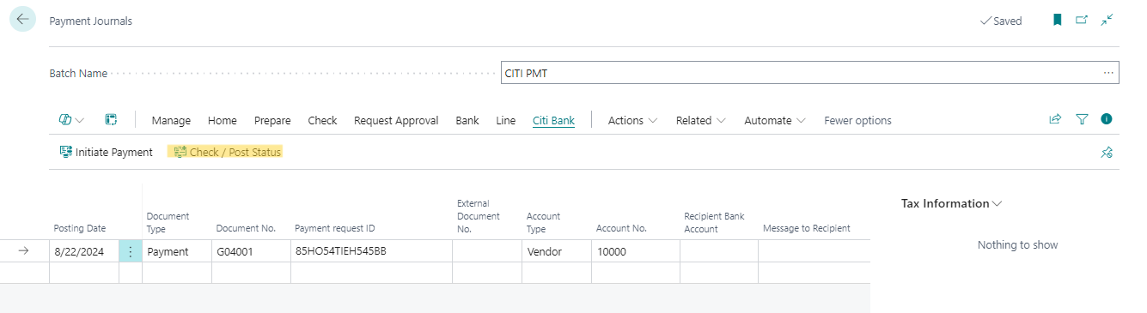

Output after response handling (With Demo Response):

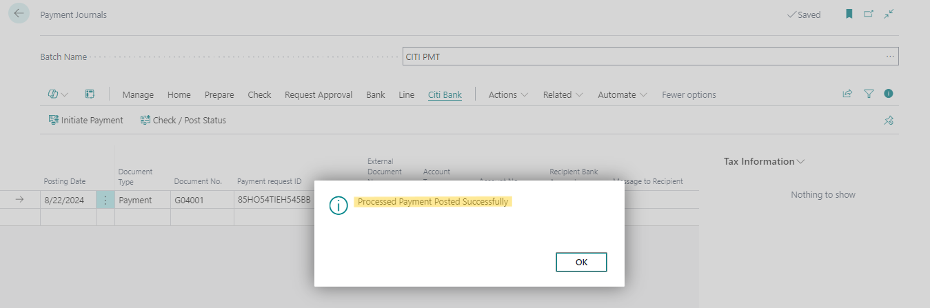

## Xmlport 50140 "Citi Payment Init Request”

**Purpose:** This XMLport is used to create a structured XML request for initiating payments through Citi Bank's API. It helps in transforming payment journal lines from Business Central into the required XML format, facilitating the integration with Citi Bank's payment initiation system.

## Codeunit 50142 "Citi Intg API Handler”

**Purpose:** This codeunit is designed to handle API interactions with Citi's services for payment initiation, payment status inquiries, and statement retrieval. It includes procedures for obtaining OAuth tokens, initiating payments, sending payment status inquiries, and initiating statements.

**Procedures**

**1. GetAuthToken()**

**Purpose**: To authenticate API requests by retrieving an access token needed for subsequent API interactions.

**2. InitiatePayment(var GenJnlLine: Record "Gen. Journal Line")**

**Purpose**: To send a payment initiation request to Citi’s payment services API.

**3. SendEnhancedPaymentStatusInquiry(var GenJnlLine: Record "Gen. Journal Line")**

**Purpose**: To check the status of a previously initiated payment.

**4. InitiateStatement(AccountNumber: Text[20]; FromDate: Date; ToDate: Date; OAuthToken: Text)**

**Purpose**: To retrieve account statement information for a specified date range.

**5. GetEncodedClientSecret()**

**Purpose**: To prepare the credentials for inclusion in the API request headers.

**6. GetExpiryTime(ExpiryDuration: JsonToken): Time**

**Purpose**: To determine when the access token will expire and needs refreshing.

**7. GetPaymentInitXMLPayload(GenJnlLine: Record "Gen. Journal Line"): Text**

**Purpose**: To create the necessary XML format payload for payment requests.

**8. GetPaymentStatusPayload(GenJnlLine: Record "Gen. Journal Line"): Text**

**Purpose**: To format the XML required for querying payment status.

## Codeunit 50141 "Citi Intg Encryption Handler"

**Purpose:** This codeunit is designed to support cryptographic operations required for secure communication with CitiBank. It ensures that data exchanged with Citi Bank is signed and encrypted appropriately, adhering to security standards.

# 3. Statement - Account Details API’s

| **Object Name** | **Object Type** | **Development Type** |
| --- | --- | --- |
| Bank Acc Rec Ext | Page | Extension |

## 

## Page Extension 50143 "Bank Acc Rec Ext"

## Purpose: This page extension is aimed at facilitating the initiation of Citi Bank statements directly from the "Bank Acc. Reconciliation List" page. It provides users with a streamlined method to start the statement process, enhancing efficiency and integration with Citi Bank's systems.

## 